For the hands on project we elected to study the differences in bandwidth usage between Ctirix Metaframe and Windows Terminal Services. Below you will be a detailed description of the method we used in our tests and any setup needed to reproduce our results.
Our initial testbed consisted of two Windows 2000 Professional clients with no service packs installed and one Windows 2000 Server with service pack four, the service pack required to install Microsoft Office, installed. We installed the latest version of Ethereal (http://www.ethereal.com) and the latest version of the WinPcap drivers (version 0.10.7 and 3.0 respectively at the time of this writing) on each of the clients. In addition to this, we installed the Citrix client, Windows Terminal Services client, and the new Remote Desktop Connection client. MS Office 2003, Citrix Metaframe and Terminal Services were installed on the server. The following diagram exhibits the layout of the machines.
The three machines were assigned private class C addresses and isolated on a dedicated switch. In order to compare bandwidth we ran three different tests. These tests were: streaming video, active typing in MS Word, and printing from notepad. Each test was conducted three times on each of the aforementioned client/server combinations in order to calculate an average score.
For the streaming video test, we obtained an AVI file from the internet and played it in repeat mode under Windows Media Player on the client (remotely invoked…video stored on the server). Ethereal was then used on the server to capture a packet stream for 45 seconds. Upon completion of the packet capture, the summary information for the capture was viewed in Ethereal. From this summary report we paid special attention to the following three items: the total number of packets captured, average packet size, and total size of all packets captured. The following screen shot is an example of the summary statistics (the three key areas have been highlighted in red for demonstration purposes).
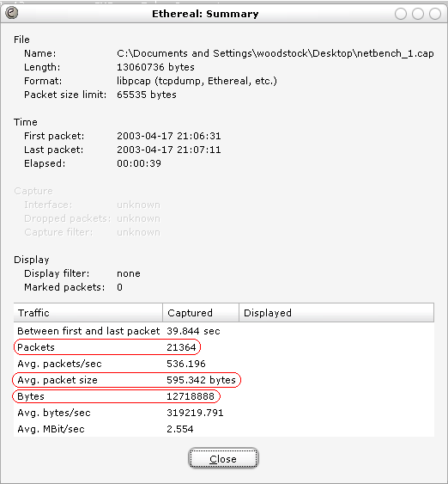
Next we ran the MS Word active typing test. To achieve a constant typing rate, we weighted down the ‘1’ key on the keyboard of the client machine and kept it pressed creating a stream of 1’s to be displayed in MS Word on the client machine (Again, MS Word was not physically present on the clients. It was remotely invoked from the server). Ethereal was also used in this test to capture packet flows between the client and the server. The same summary statistics as before were gathered and recorded.
Finally we elected to gather information on printing behavior for the three platforms. In this test, we attached an older model HP DeskJet printer to one of the client machines and opened a text file in notepad of approximately 500Kb (this file was stored on the server). The document was then printed. Slightly different from the other tests, Ethereal was started before sending the print job and only ran for 20 seconds, instead of 45 as in the other two tests.

