Lab Assignment Notes
Student Name ___________________________________________________
Date Lab Assigned _________________________
Date Lab Due _____________________________

Rational & Objective
The Internet is a network of networks, that is, it is composed of many independent or autonomous networks. Traveling from one point on the Internet to another will usually take a path across many different networks. Much like traveling from your hometown to Disney Land in Florida can take you across more than one state over many different highway systems with alternate routes to choose from before you reach your destination, traveling on the Internet will take you across different networks. Just like traffic varies on the highway system, traffic varies on the Internet.
In this lab, we explore the Internet in general to obtain a basic idea of this “networks of networks.” The two main objectives of this lab are:
- The student will become familiar with various terms and tools used in exploring the Internet and use those tools to produce a report concerning a selected URL’s IP address and route taken to that URL.
- The student will be able to explain what is meant by the Internet being a “Network of Networks” and draw a simple graphic depiction of this concept.
The complete list of terms and tools used in this lab are listed below.
PING | TRACERT | HOP | IP address
MAC address | Host | Network | IPCONFIG
NEOTrace | Cloud | Access Router | Boarder Router
Core Router | URL | DHCP | ARP

Perform this lab as an individual from a workstation connected to the Internet somewhere on planet earth. This lab is written for an NT workstation in the DeVry lab.

Instructions
This lab will have you use programs to determine IP addressing and routing through the Internet. The programs you will use are PING, TRACERT, NeoTrace and IPCONFIG. Note: NeoTrace many need to be installed. Help tables are in the back of the lab.
REPORT: You will need to generate a simple report concerning routing information obtained from this lab. Most of the commands you will use can have their output redirected to a file on the hard drive. Then it becomes a simple case of cut and past for a report. Redirect these outputs to a text or doc file on the C-drive. You can then print them out for reference later.
Staple all printouts to your report. Your report should follow the formats handed out in class.

Procedures
- Bring up your workstation in NT for connection to the DeVry LAN. Login using your student account.
- Insure you are connected to the Internet by opening Microsoft Internet Explorer and going to http://www.Yahoo.com. Close this window when finished.
- Open up a command line window. You can do this by selecting Start, then Run, then typing either cmd or command and pressing Enter. Once the command window is opened, enter “CD/” to get the prompt to the root. Your window should look similar to this.
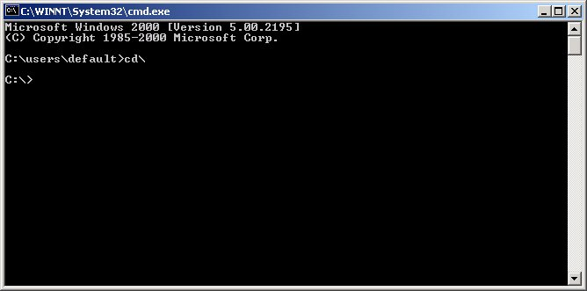
- You will want to use either a floppy or your network student drive to save your reports to for editing and printing later.
- When you boot your station and connect to the network, it sends out and ARP request and obtains a "dynamic" IP address from the DHCP (Dynamic Host Configuration Protocol) Server via an ARP reply. Routers and servers contain "static" IP addresses. We can obtain information about the stations configuration using the IPCONFIG command. For help on this command, type “IPCONFIG /?”
- In the command window, type ipconfig /all and press enter. You will obtain an output with information similar to example 1.
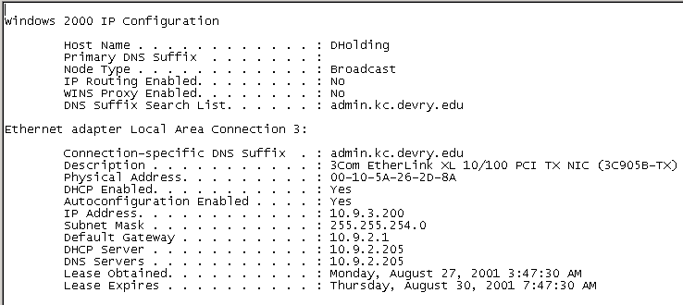
EXAMPLE 1: IPCONFIG
- Example 1 output shows the configuration information for the station. There are two sections: Windows configuration and the Adapter configuration. Note the following
  - The host name actually contains the host name of the station and the domain information. Here, the host name is Dholding (the name prior to the first period). The remaining part contains domain and sub-domain information.
  - The adapter sections tell the kind of adapter your station has as well as the MAC or Physical address.
  - It also provides your with the IP address of your station, the subnet Mask used as well as IP addresses for the default Gateway, DHCP Server, and DNS server.
- To send this output to a file, enter the following command.
  - IPCONFIG /ALL > A:\IPCONFIG.TXT
  - The fill will be sent to the floppy drive. Once you have your command prompt back, the process is complete. Open the file and add your name and class section to the top left of the document.
  - Print it out in landscape mode and answer the following questions.
- Find the following information for your station.
  - What is your Host name?
  - What is your MAC address?
  - What is the Gateway IP address?
  - What is DHCP IP address?
  - What is the DNS IP address?
- Network administrators occasionally must check to see if a site or IP address is up and running. This is easily done with the PING command. PING provides a way of “knocking” on the door of an IP address to see if it is up and running. It also provides us with round-trip time information.
When you use the PING command, it pings the destination station four times and returns the roundtrip time for each ping along with a statistics summary. (example 2)

Example 2: PING
Pinging 10.9.2.1 with 32 bytes of data:
Reply from 10.9.2.1: bytes=32 time<10ms TTL=255Reply from 10.9.2.1: bytes=32 time<10ms TTL=255Reply from 10.9.2.1: bytes=32 time<10ms TTL=255Reply from 10.9.2.1: bytes=32 time<10ms TTL=255
Ping statistics for 10.9.2.1: Packets: Sent = 4, Received = 4, Lost = 0 (0% loss),Approximate round trip times in milli-seconds:
Minimum = 0ms, Maximum = 0ms, Average = 0ms
- Within the LAN, you should have less than 10 milli-seconds to each node. PING the following stations and determine that you have such a response time.
  - DHCP Server response time: _____________________________
  - Default Gateway response time: ___________________________
- Another thing that occurs when we PING stations in our LAN is the MAC and IP addresses of each station we ping is added to a cache memory in our system. We can use the ARP command to retrieve this information. Enter the following command: ARP –A and list the MAC addresses for the following nodes. You may have to PING these nodes to refresh their entries in your ARP Table. For help on the ARP command add “/?” to the end of the command.
  - DHCP Server: _____________________________
  - Default Gateway: ___________________________
- When we venture out on the Internet, we will travel across several autonomous networks to get to our destinations; thus, our travel time greatly increases. Use PING to determine the following information of www.yahoo.com.
Use the command
PING WWW.YAHOO.COM
  - The IP address of Yahoo.
  - What is IP the license class?
  - Ping Yahoo three or four times and determine the minimum and maximum round trip time for your packet.
Minimum:
Maximum:
- PING is a useful command for “knocking on the door” of an IP address, but it does not tell us how we got to that address. For this we use the command TRACERT to collect data on the route and hops involved. For help on the TRACERT command add “/?” to the end of the command.
  - Determine how many routers there are between your station and the Yahoo servers.
- TRACERT provides information that tells you how many networks your packets passes through. Not the printout shown in example 3 below. You can match the IP address in the first two hops to IP addresses obtained in your IPCONFIG printout. There are devices in the DeVry LAN. The last device in the DeVry LAN connects it to the ISP provide. It is the access router and the next device is the boarder router for the ISP.
Tracing route to www.yahoo.akadns.net [64.58.76.176]
over a maximum of 30 hops:
1 <10 ms <10 ms <10 ms 10.9.2.9
2 20 ms 10 ms 10 ms 205.160.208.30
3 10 ms 20 ms 20 ms bar12-serial6-0-0-4-0.Chicagochd.cw.net [208.173.112.5]
4 10 ms 20 ms 20 ms acr2-loopback.Chicagochd.cw.net [208.172.2.62]
5 10 ms 30 ms 30 ms exodus-communications.Chicagochd.cw.net [208.172.1.214]
6 20 ms * 20 ms bbr01-g3-0.okbr01.exodus.net [216.34.183.65]
7 50 ms 40 ms 40 ms bbr01-p2-0.whkn01.exodus.net [206.79.9.134]
8 40 ms 40 ms 51 ms bbr02-g5-0.whkn01.exodus.net [216.35.65.84]
9 40 ms 50 ms 50 ms bbr01-p3-0.stng02.exodus.net [209.185.9.102]
10 40 ms 50 ms 50 ms bbr01-p6-0.stng01.exodus.net [209.1.169.197]
11 50 ms 50 ms 50 ms dcr03-g9-0.stng01.exodus.net [216.33.96.145]
12 40 ms 50 ms 50 ms csr21-ve241.stng01.exodus.net [216.33.98.18]
13 50 ms 361 ms 310 ms 216.35.210.122
14 40 ms 50 ms 50 ms www7.dcx.yahoo.com [64.58.76.176]

Trace Complete
Example 3: TRACERT to www.yahoo.com

- There are three basic classifications of routers: Access, Boarder and Core. Reference figure 1 to the right. Access routers provide access from the customer site to the ISP via the boarder router. Boarder routers are on the boarder or edge of the ISP network and connect to Access routers, boarder routers of other ISPs or to the core routers. Core routers make up the high speed backbone of an ISP and only connect to other core or boarder routers.
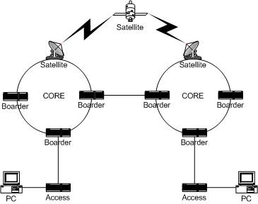
Figure 1
- Notice from the TRACERT example that a lot of the routers have names. Those names should be meaningful for the location and purpose of the device. They also provide information about whose network you are on: cw.net & exodus.net.
- You should see from the TRACERT example, there are two LANs and two WANs that your packet goes through. Name them (the first one is done for you).
  - DeVry Kansas City LAN

- Command line applications such as PING and TRACERT are fine and dandy, but there are GUI applications that combine several features of command line programs. NeoTrace is one of them.
  - You will need access to NeoTrace. Check your computer you are using and determine if NeoTrace is installed on your system. If not, it should be available on the faculty shares on the school network or may be obtained at http://www.neoworx.com/ for a trial version.
- Once installed and running, NeoTrace looks like/similar to the screen below (figure 2). Note that the application window has a “Target” area where you enter the FQDN (fully qualified domain name) or IP address you want to trace.
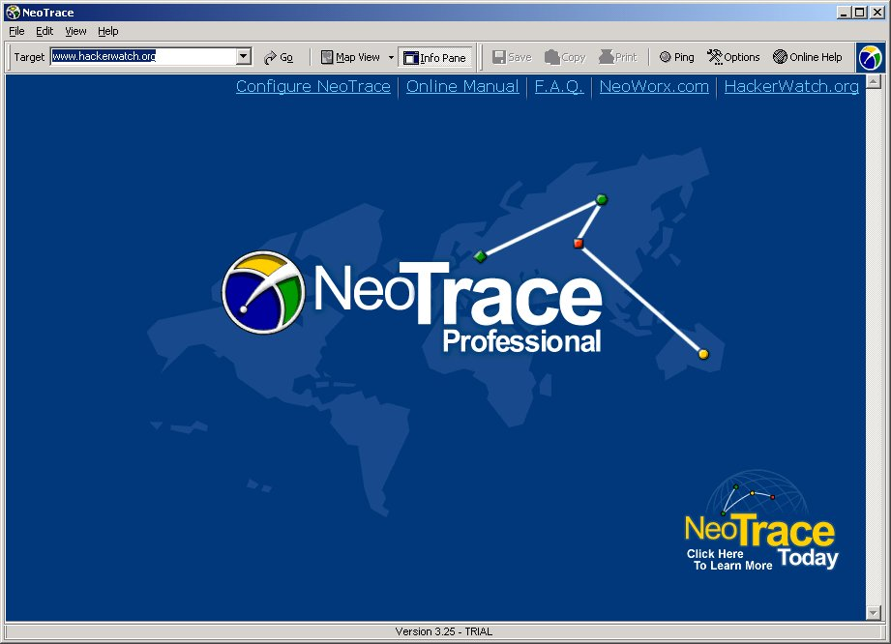
Figure 2
- Enter in www.yahoo.com for your target search. After a bit, the screen should change to the following (figure 3). The information pane is toggled on/off by the “Info Pane” toolbar button. The info pane provides you with a previous and next button to set through the locations of each nodes or internetworking device found by the application.
Step through the nodes using the buttons on the info pane and notice the yellow dot on the map changes.
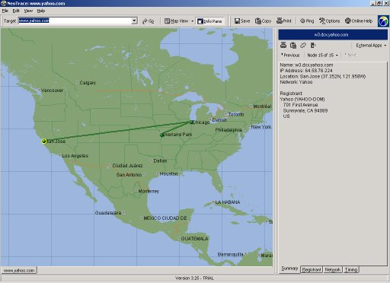
Figure 3
- On the right side of the “Info Pane” toolbar button is the drop-down menu for the main screen. It is currently on the Map display. Change it to the “list View.” The main display should now look like figure 4 below.
Notice that the list looks very similar to a TRACERT function and there is a graph that provide response time per node. As you watch the display, you’ll notice that the node listing flash blue every so often. This is the application refreshing the list.
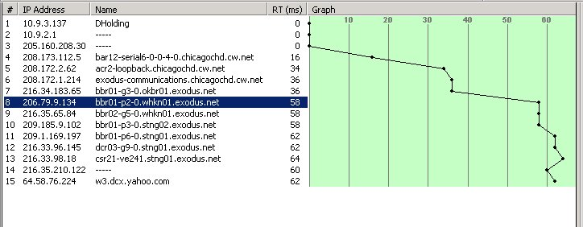
Figure 4
- The Node view looks similar to figure 5 below.
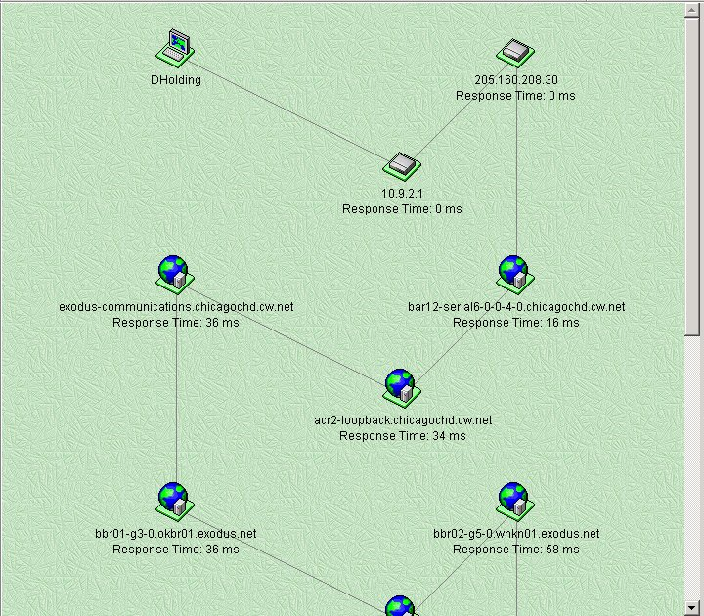
Figure 5

Lab Assignment Section
Use the tools you just explored to complete the following assignment. Using the FQDN: www.anzturkishguesthouse.com, produce a report titled “INTERNET SEARCH” that contains the following items and answers the questions on this page. Place your name and date in the upper left corner. Attach the following single page items to your report with a staple in the upper left corner.
- Windows NT IP Configuration information
- A single PING to the FQDN
- A single TRACERT to the FQDN
- What is the Host name of your station?
- What is the IP address of your station?
- What is the IP address of the FQDN?
- What is the minimum packet trip time to the FQDN?
- What is the maximum packet trip time to the FQDN?
- How many routers between your host and the FQDN?
- How many WAN networks between your host and the FQDN?
- Where is this IP located?
- At what IP does the packet trip time greatly increase>

IPCONFIG
IPCONFIG (Windows NT IP Configuration) displays the current IP addressing, subnet masking, and default gateway information for the current station.
Usage:
ipconfig [/? | /all | /release [adapter] | /renew [adapter]]
The default is to display only the IP address, subnet mask and default gateway for each adapter bound to TCP/IP.
For Release and Renew, if no adapter name is specified, then the IP address leases for all adapters bound to TCP/IP will be released or renewed.
/? | Display this help message.
/all | Display full configuration information.
/release | Release the IP address for the specified adapter
/renew | Renew the IP address for the specified adapter.

TRACERT
TRACERT(Trace route) provides tracing of an active route to a destination address by returning trip time and router information for each router involved in the path.
Usage:
TRACERT[-d] [-h maximum_hops] [-j host-list] [-w timeout] target_name
Options:
-d | Do not resolve addresses to hostnames.
-h maximum_hops | Maximum number of hops to search for target.
-j host-list | Loose source route along host-list.
-w timeout | Wait timeout milliseconds for each reply.

PING
PING (Packet InterNet Groper) is an TCP/IP application service that can be used to test for connectivity between any two systems in the network. PING allows you to send an inquiry packet to a known IP address. It will return the number of bytes sent in the packet and the time it takes for the round trip to the server and the Time-To-Live value.
Usage:
ping [-t] [-a] [-n count] [-l size] [-f] [-i TTL] [-v TOS] [-r count] [-s count]
[[-j host-list] | [-k host-list]] [-w timeout] destination-list
Options:
-t | Ping the specifed host until interrupted.
-a | Resolve addresses to hostnames.
-n count | Number of echo requests to send
-l size | Send buffer size.
-f | Set Don't Fragment flag in packet.
-i TTL | Time To Live.
-v TOS | Type Of Service.
-r count | Record route for count hops.
-s count | Timestamp for count hops.
-j host-list | Loose source route along host-list.
-k host-list | Strict source route along host-list.
-w timeout | Timeout in milliseconds to wait for each reply.

Student Comments
Provide feedback and comments on this lab here.

